**CS551 Advanced Software Engineering**

**Third Increment Report**

**Project Title: PickMeUp**

**Submitted by**

PG6 (SG14 and SG15)

Ponnada Rahul (Class ID-39)

Ghanta Surya Prabha (Class ID-19)

Tummala Anvesh (Class ID-48)

Anumolu Satish Chowdary (Class ID-2)

**Import Existing Services/API**

In this Increment, we implemented three web services. The web services we implemented are as follows - Admin registration to register for administrators, Admin Login to verify the admin credentials for validating him, Admin Home that will get the Array of list of Volunteers and their assigned students. The main improvement we made in this increment is creation of Admin, finalizing the algorithms with all the modifications required.

Modifications to our previous web services include:

Student Registration: After the successful registration student will be assigned a volunteer automatically and mail will be sent to admin, volunteer and student about the newly assigned pickup.

Volunteer Registration: After a volunteer is successfully registered, the service will look for all the unassigned students and calls for the assignVolunteer method for each of the unassigned students. This will assign the students for newly registered volunteer.

-Admin Registration service for admin to register and use the app.

-Admin Login service for verifying the admin login credentials and let him use the app.

-Admin Home Page for getting all the Volunteers and their assigned students to aloe him display about the volunteers and students details, unassigned students.

- IntelligentSysytem(Modifications) service is for assigning Volunteers to students based on their matching times. Also it looks for unassigned students when a new volunteer is available and assigns him the students for pickups.

- SendNotifications(Modifications) service is for sending notifications to Volunteers when a student has been assigned. As we have included Admin this time, the notification system will be used for sending mails to admin whenever a student has been assigned with a volunteer.

**Detail Design of Services**

**User Stories:**

We have three stories in iteration3

1. As an admin, I want to login so that I can get access to the application.

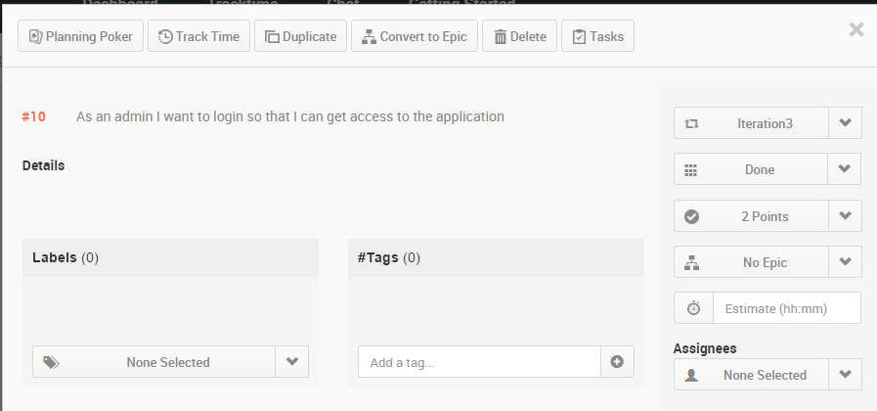

1. As an admin, I want to create an account and have admin privileges so that I can access all the students and volunteer details.

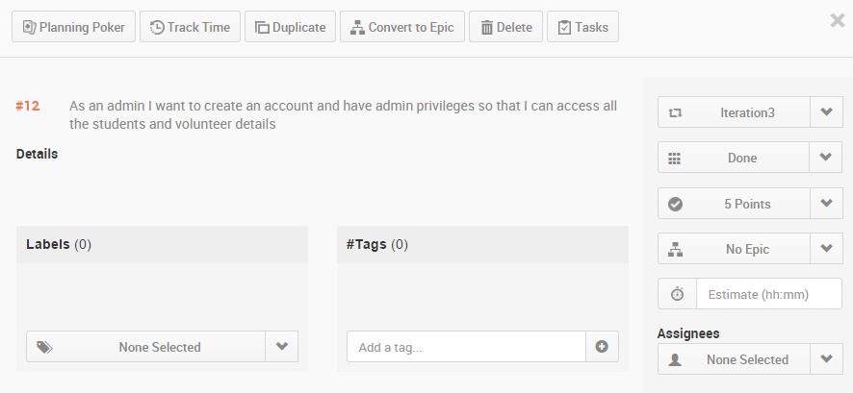

1. As an admin I want to access all the details of students and volunteers so that I can see who is assigned to who for pick up.

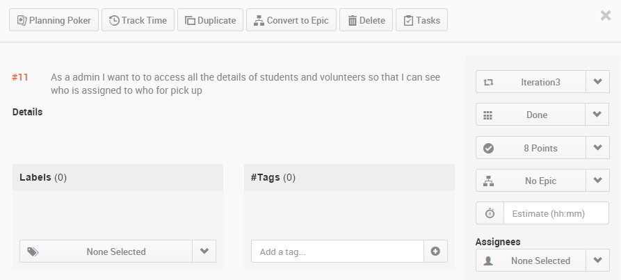

**Service description:**

Admin Registrationis for registering an administration by giving his details like name, Phone Number, Email ID, University Name. Admin will be only one for a university.

**Admin Login** is for verifying the login details entered by the user and checking them with the login details in the Database of the admin. If he is a valid admin, then he will be allowed to uses the application.

**Admin Home:** Once an administrator is being validated he has to get the details of all the Volunteers and their assigned students details. This service will give the arraylist of students with the volunteer at first and followed by the list of assigned students.

**Student Login:** After the successful login of the student, the intelligent system will be automatically invoked and assigns a volunteer and send the notification mail to admin, assigned volunteer and student. The admin is notified that a Volunteer has been assigned for picking a student, the volunteer will be notified that a student is being assigned for pickup and student will be notified with the assigned volunteer name.

**Volunteer Registration:** After a volunteer is successfully registered, the service will look for all the unassigned students and calls for the assignVolunteer method for each of the unassigned students. If this newly added volunteer is available for any unassigned student then those students will be assigned for newly added volunteer. Also Emails will be sent to all the assigned students, volunteers and admin.

*Intelligent system* is a web service that is the core component of this project. The main task of this system is allot volunteer to students upon their arrival timings.

Assigning a volunteer is a part of the web service that is invoked when a volunteer is registered or change his available timings. This service is invoked after the volunteer has successfully registered there by checking his availability timings against student arrival timing. The algorithm that we developed here follow certain rules in assigning a volunteer to the student.

Assigning a student is also a part the of web service that is invoked when the student gets registration. His arrival timing is checked against the volunteer availability. If any volunteer is available he is assigned to that volunteer.

These web services return JSON data back to the client to verify the operation has successfully completed on the server side. REST uses JSON as it data exchange format so as in here for all the web services. Microsoft SQL server is the persistence storage that these services store data on to table and retrieve them for later verification, validation and population purposes.

**sendNotification:**

sendNotification service will send email notifications to volunteer and users regarding their pickup. When a student is assigned to a volunteer. Both receive an email notification of the service. Email notification can be set to different services such as registration, change in timings and update to a new volunteer and so on. Notifications will be sent to the administrator, Volunteer and students.

**IntelligentSysytem:**

IntelligentSysytem service will assign volunteers to students based on the available times of Volunteers and students arrival times. If there are is no volunteer available for the pickup of a student, it will send email notification to Admin to have volunteer for picking that student. The algorithm we followed to assign Volunteers is as follows.

**Algorithm**

We have come up with our own algorithm to assign volunteers for picking students. We have taken input for the available times of Volunteers for a week, assuming he will have a recursive schedule that will be same for all weeks. For each day in the week, we have taken 8 bit input, each bit refers to his availability of every 3 hours. So, the volunteers 24 hours availability is taken input for each 3 hours i.e. {0-3, 3-6, 6-9, 9-12, 12-15, 15-18, 18-21, 21-24}.

**Requirement1:** The Volunteers availability is to be stored in DB as follows, if a Volunteer is available on Monday, Tuesday, Saturday and if he is available from 12-18h on Monday, from 21-24h on Tuesday, fully available on Saturday, he will input his availability as (48-00110000, 128-10000000, 0, 0, 0, 255-11111111, 0). This should be stored in DB as availability of Volunteers.

**Requirement2:** The arriving time of the students is to be stored in the DB as DateTime format.

**Input:** String: StudentID

**Step1:** Extract the arrival time of the student from DB based on input StudentID.

**Step2:** Get the dayOfWeek of arrival time of student, let say Sunday.

**Step3:** Look for the time slot student is coming. I.e is he is coming at 11:15 AM the his daySlot will be 8 - (00001000) bit 1 at (9-12 time period).

**Step4:** From the details of the dayOfWeek and time slot, query the Volunteer database for the week schedule of dayOfWeek

such that Get TOP of VolunteerAvaialability &(bitwise AND) daySlot !=0 AND sort by noassignedstudents ASC.

Then we will get the Volunteer who is available for the pickup of student having less no of students being assigned.

**Step5:** Notify the Volunteer about the assigned student details.

**Step6:** Return status.

**Sequence diagrams:**

**Admin Registration:**

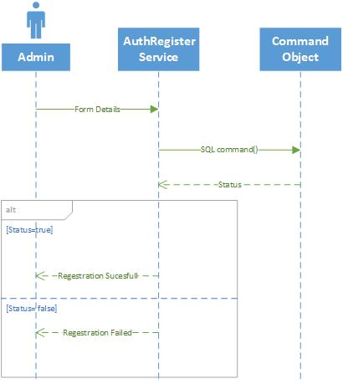

**Admin Login:**

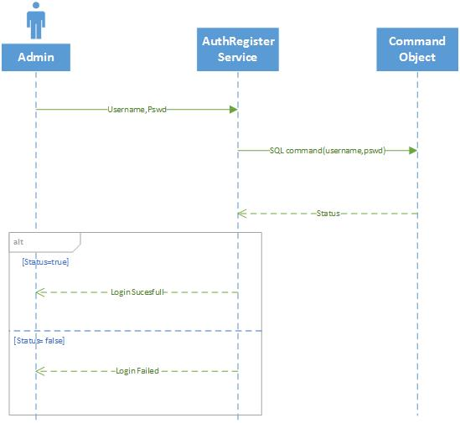

**Getting Admin Home Page Details :**

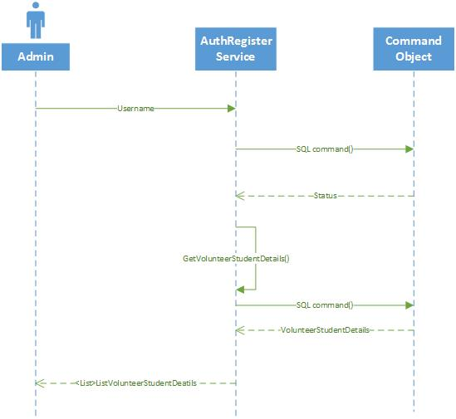

**Student Registration:**

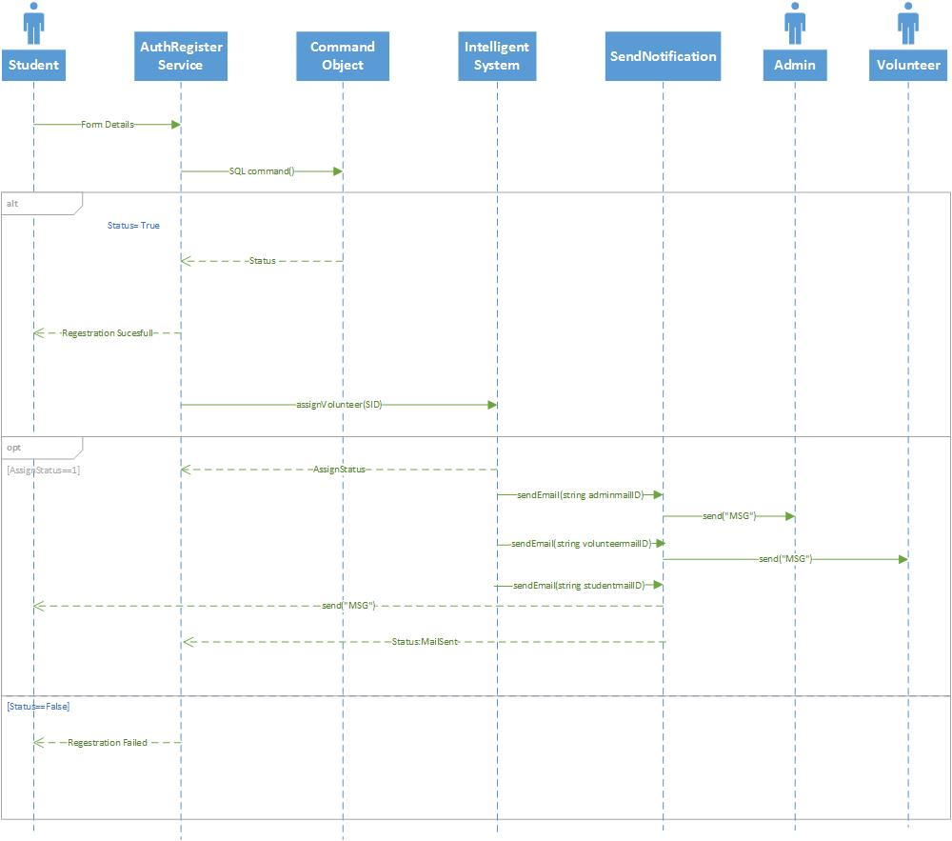

**Volunteer Registration:**

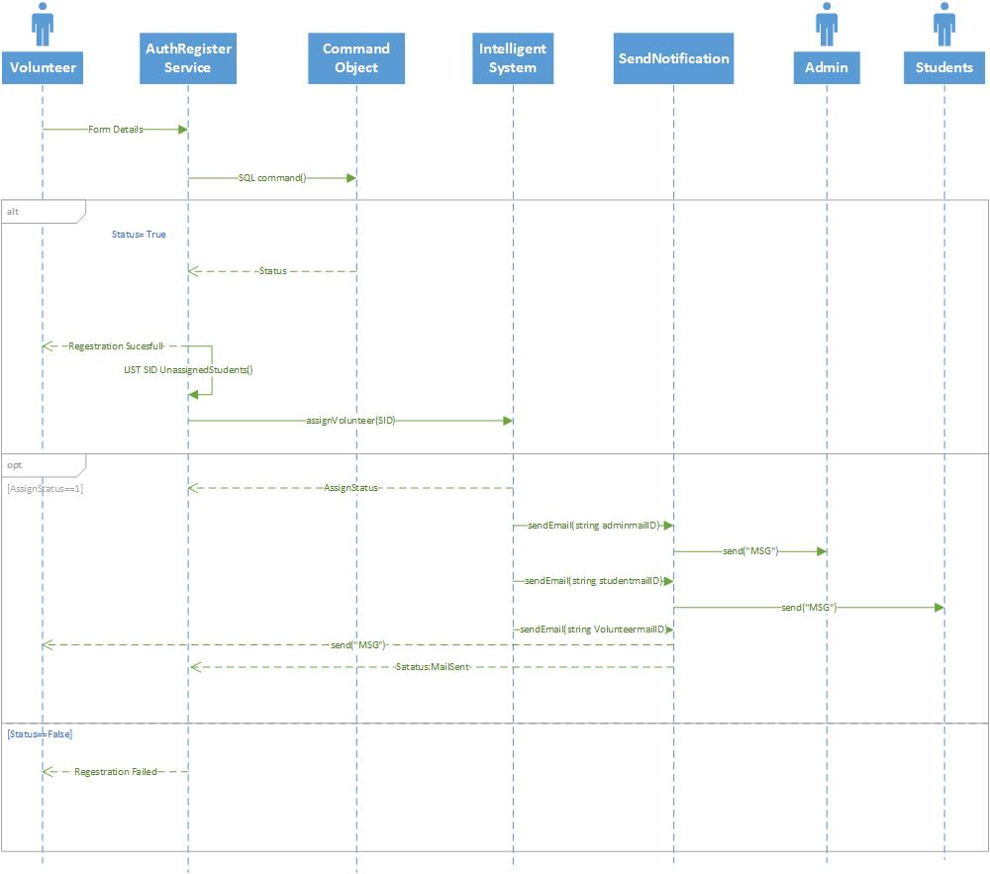

**Class Diagram:**

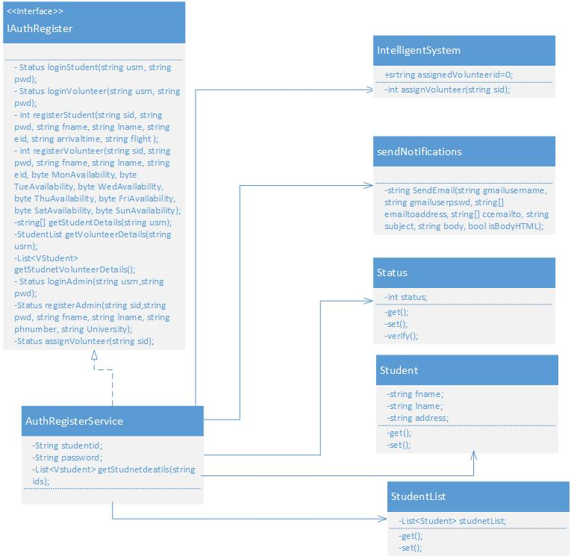

**Design of Mobile Client Interface:**

Mobile client interface is an Android application which is a rich client. An application is considered rich client if it has all the UI required on client’s side. Overall UI design is developed using Android studio. We are using the Base.V21.Theme.AppCompat theme for our application and Nexus 5 API 21 as emulator for testing our application. As of now, for the third iteration, we have designed 2 screens and updated 3 screens that already exist.

**New Screens**

1. Admin Registration screen
2. Admin home screen after successful login.

**Updated Screens**

1. Start Screen which prompts user to select Student, Admin or Volunteer
2. Login Screen for Student, Admin and Volunteer
3. Volunteer Registration Screen.

User Interacts by a touch based smartphone there by navigating to other screens and perform operations on the server. Typical mobile client flow of operations is as follows. When the student, admin or a volunteer install the app, they are asked to identify themselves (to distinguish between student, admin and volunteer). Then they are redirected to a login page where already existing users can login and new users can register. Volunteer registration is modified in order to allow the volunteer to select the available time slots for all the 7 days of a week. After successful registration, users are navigated back to the Start screen form where they can login to their respective home pages (Student Home Screen, Admin Home Screen & Volunteer Home Screen). Admin Home Page will consist of details of all the volunteers and the students assigned for each volunteer.

**Design of Unit test cases (using NUnit tool):**

Test cases are designed to test the Login and Registration services, Assign Volunteer service, Admin Home details. This is implemented using visual studio and executed by NUnit Client. Our test case consists of four methods to test the Student login, Volunteer Login, Admin Login Student Registration, Volunteer Registration, Admin Registration, Admin Home details, get student Details, Get Volunteer Student Details and Get Volunteer details functionalities. Intelligent System and notification service are tested by testing Student Registration as that service invokes the call to the intelligent system and intern invokes call to notification. Also the assigning of the students after a volunteer registration is tested.

**Implementation**

**Implementation of REST services:**

WCF (Windows Communication Framework) is used to implement REST web services on Visual Studio 2010. Web service project has an endpoint IAuthRegister.cs, which is also called as contract and Implementation of these resources is in AuthRegister.svc.cs. The implementation has several resources implemented and are ready to be consumed from a client. Resources communicate directly with the underlying database.

Registration services saves student and volunteer account information in the system. Both the services will take the respective account information from the Mobile client side and Updates the respective student or volunteer tables respectively.

IntelligentSystem service takes the input as the studentID and get the details of student from DB. It will query the Volunteer DB for the Volunteers who are available for the student pickup and assigns him for pickup. From Mobile client side whenever the student updates his flight arrival time this service gets invoked and assigns him volunteer.

Notification service is used by intelligent system to send mail to volunteer when a student is being assigned. It used the Gmail server to send mail. When Intelligent system assigns student to Volunteer then this notification service is invoked to send mail to volunteer.

The Volunteer Registration will include the getting of the unregistered student details and assigning the new volunteer for their pick up if the volunteer availability matches with the pickup times of students.

**Implementation of user interface (Mobile Apps):**

Android studio is being used to implement the Mobile App. User Interface of the app is XML based and is relatively changeable to the screen size. Two activities are created for the 2 new screens designed for this increment and 3 existing screens are modified.

1. **Start Screen (updated):** It is the MainActivity consists of three buttons student, admin and volunteer. Upon click of any button, it will navigate to Login screen and will also pass the respective button name to distinguish among student, admin and volunteer for the next levels of navigation from login screen. A new background image is also added for the start screen layout file to make the application more meaningful and attractive.

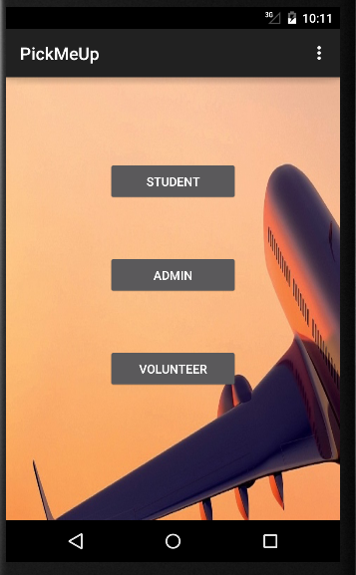

1. **Login Screen (updated):** It is the LoginActivity which consists of StudentID, Password fields and Login, Sign Up buttons. Now, we have provided the login and registration functionality for the Admins. Existing users will navigate to their Home screen by the providing the login details. A new private class AuthenticationService is written inside the LoginActivity which uses HTTP request to call the Login Service from the Mobile client side. Upon click of the login button, respective login service is called to validate the login credentials and response of true or false is returned. If true is returned, a Toast message “Login Successful” is displayed and the user will be navigated to the respective Home screens. If false is returned, a Toast message “Invalid Credentials” will be displayed. A new background image is also added for the start screen layout file to make the application more meaningful and attractive.

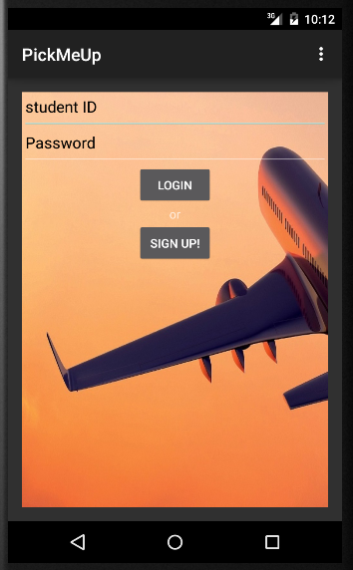

1. **Volunteer Registration Screen:** It is the VolunteerRegActivity which consists of fields like StudentID, Password, FirstName, LastName, Email ID, Gender, Phone No, Address and Available Days fields to create a volunteer account.

Available Days is divided into 7 days of week. Each day is further divided into 8 slots, each slot of 3 hrs of the total available 24 hrs. A check box is designed for each of the 8 slots for all the 7 days of the week. Upon selecting any checkbox, volunteer assures his availability and a new bit value 1 (0 if not checked) is assigned and final value is calculated for each day. Based on this final value of each day, backend REST service will know the availability of the volunteer for that specific day of the week.

Except the available days, all the other fields are mandatory fields and Validated after the click of Register button. A new service VolunteerRegistration is written inside the VolunteerRegActivty which uses HTTP request to call the Volunteer Registration service from the mobile client side. Upon validation of validation of required fields, this service will be called to create an account for the volunteer. A new Toast message “Account Created Successfully – Please Login” will be displayed to the user and is navigated to the Start Screen.

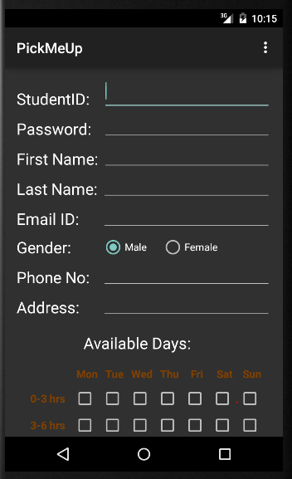 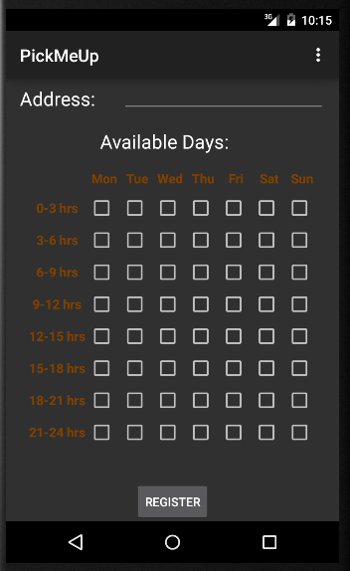 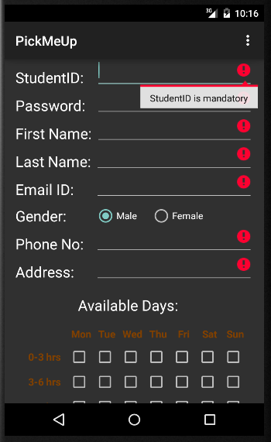

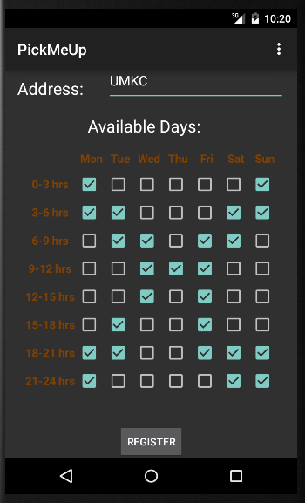 

1. **Admin Registration Screen**: It is the AdminRegActivity which consists of fields like StudentID, Password, FirstName, LastName, Email ID, Gender, Phone No, Address and University fields to create an Admin account. All the fields of this activity are mandatory fields validated after the click of the registration button. A new service AdminRegistration is written inside the AdminRegActivty which uses HTTP request to call the Admin Registration service from the mobile client side. Upon validation of validation of required fields, this service will be called to create an account for the admin. A new Toast message “Account Created Successfully – Please Login” will be displayed to the user and is navigated to the Start Screen.

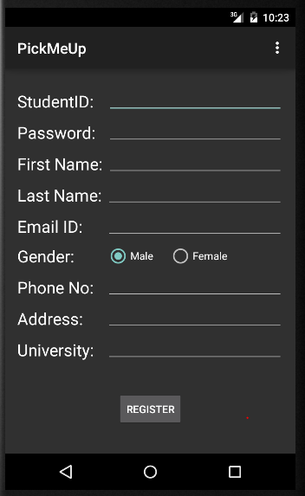 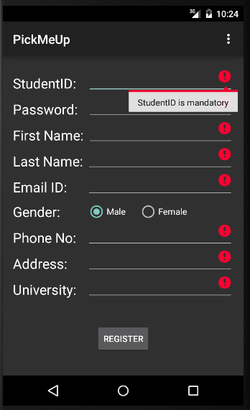 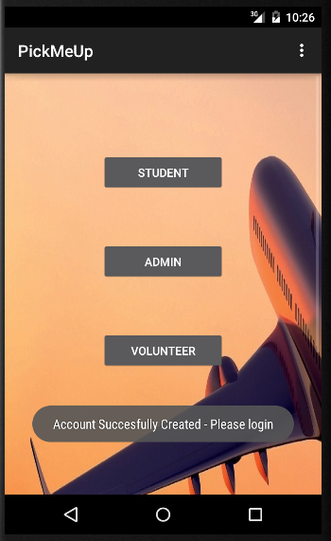

1. **Admin Home Screen:** It is the AdminHomeActivity which consists of table which all the details of the volunteer and the students assigned to that respective volunteer. Volunteer details include the volunteer ID and Volunteer username whereas student details include student ID, student Name and their Arrival Date.

A new service AdminHomeService is written inside the AdminHomeActivty which uses HTTP request to call the Admin home service from the mobile client side.

Upon successful login of the admin, admin home rest service will be called and the response of the respective will be captured and displayed in the Admin Home screen. TableRows will be programmatically appended based on the JSON response of the web service.

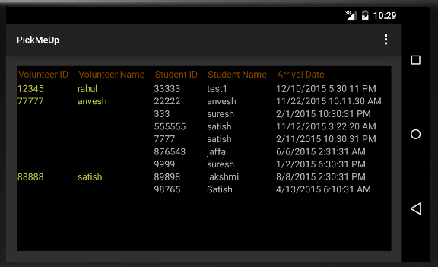

**Implementation of test cases:**

Test cases are implemented by using visual studio and executed by NUnit Client. Our Nuint class Service consists of Ten test methods. They are as follows:

* testassignVolunteer - to test for assigning a volunteer for a student.
* testgetStudentDetails - to test the details of the students returned.
* testgetVolunteerDetailsFailCase - to test the details of the students assigned for Volunteers. This is a fail case as the expected output is excluding the newly assigned student.
* testLoginAdmin - to test the admin Authentication process.
* testLoginStudent- to test the student Authentication process.
* testLoginVolunteer - to test the Volunteer Authentication process.
* testRegistrationAdminFailCase – to test the fail case of the admin by registering with the already existing ID. So it will not allow us to register with duplicate ID.
* testRegistrationStudent - to test the student Registration process that successful assignment of the Volunteer for the student will return 1
* testRegistrationVolunteer - to test the volunteer Registration Process.

**Test Cases:**

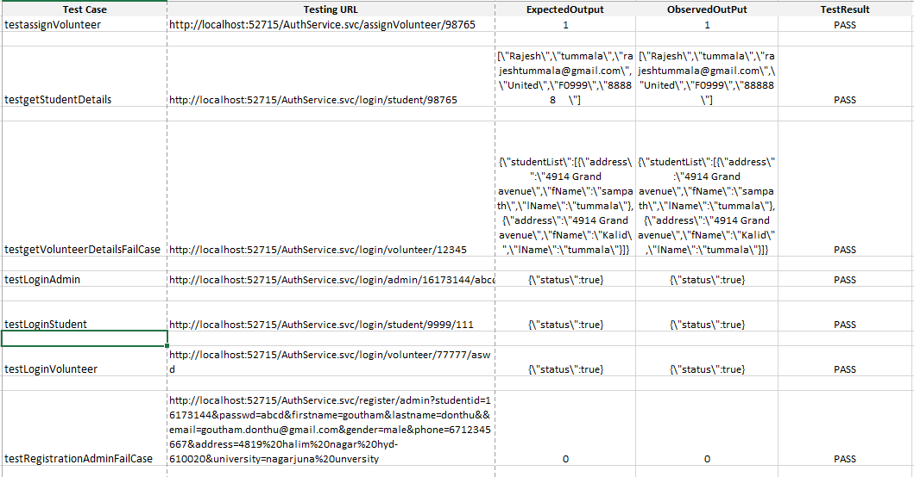

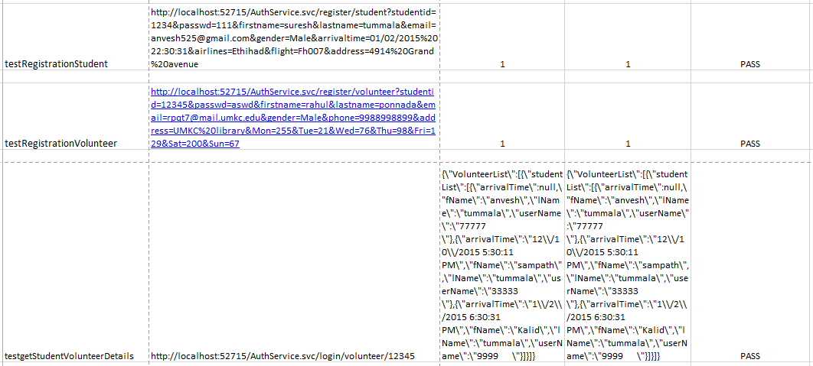

**Testing:**

**Functional Testing : Perform Unit testing (using NUnit tool)**

All the six test cases are successful when our service test in TestWS class is executed with NUnit Client.

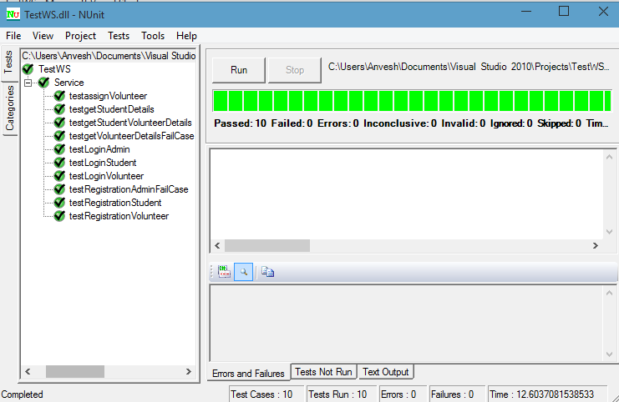

**Deployment Testing : Runtime performance testing**

**Tool Used for performance testing : Chrome Dev Tool**

**Volunteer Registration response time (Successful):**

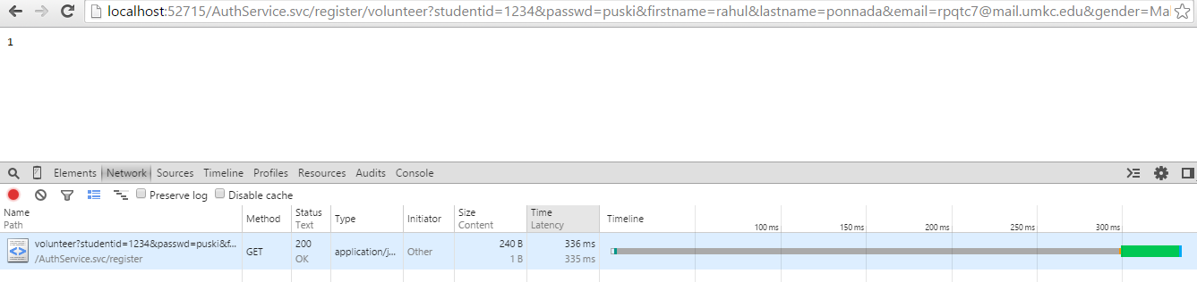

**Volunteer Registration with automatically assigning the students (assigning volunteers for unassigned students)**

We have made 10 students unassigned and have seen the response time for assigning volunteers, mailing for all those students.

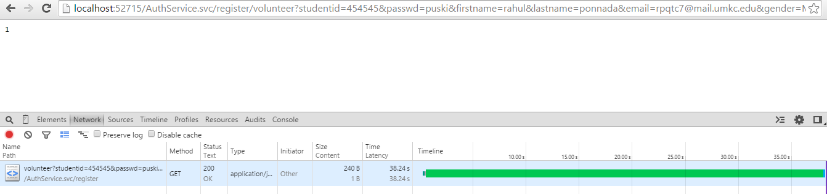

Interesting result: For assigning volunteers for all the 10 students and to send mails(almost 30 mails (3*10)) it took 38 sec. I think its not that bad, at the same it is not high response time.

**Login Student response time: *(Unsuccessful Login)***

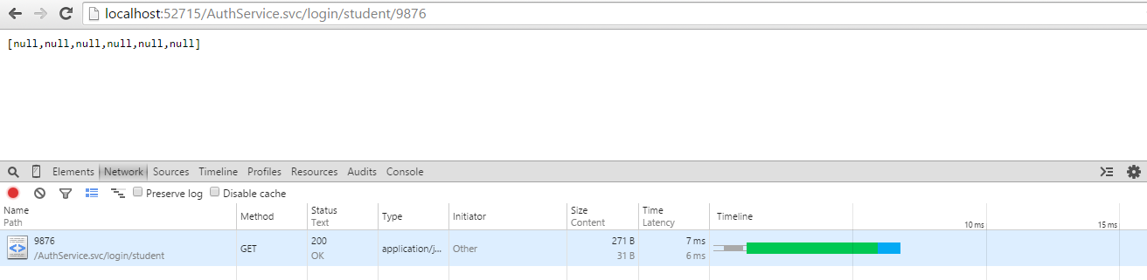

**Login Student response time: *(Successful Login)***

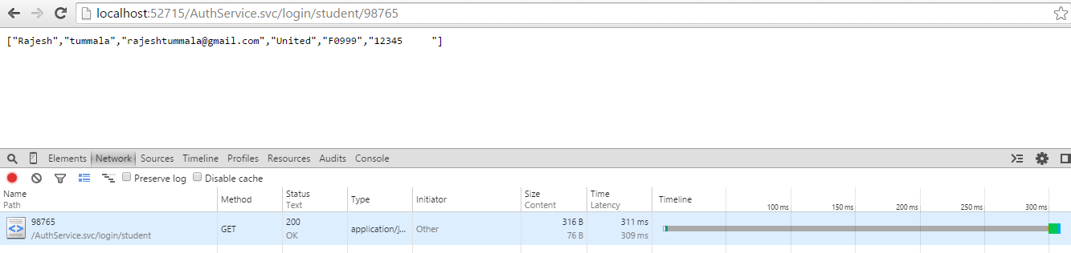

**Student Registration response time: (Failed case)**

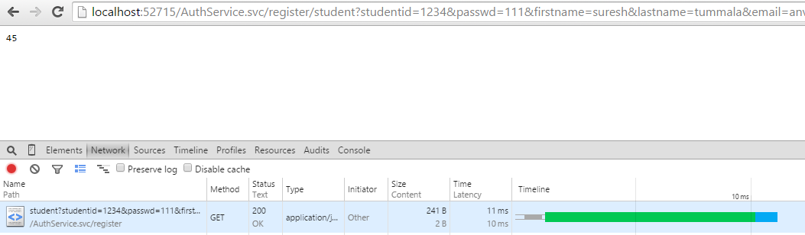

**Student Registration response time: (Successful case)**

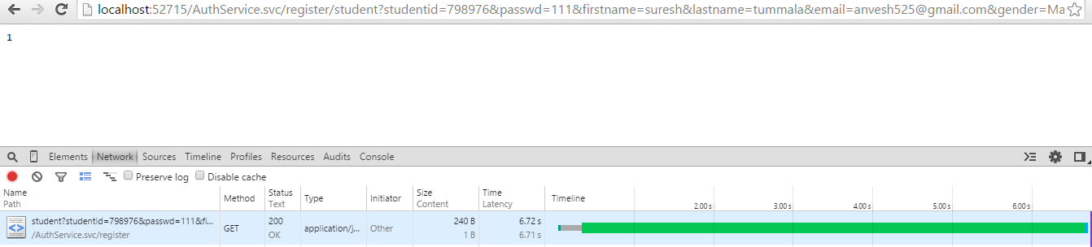

**Admin Login response time:**

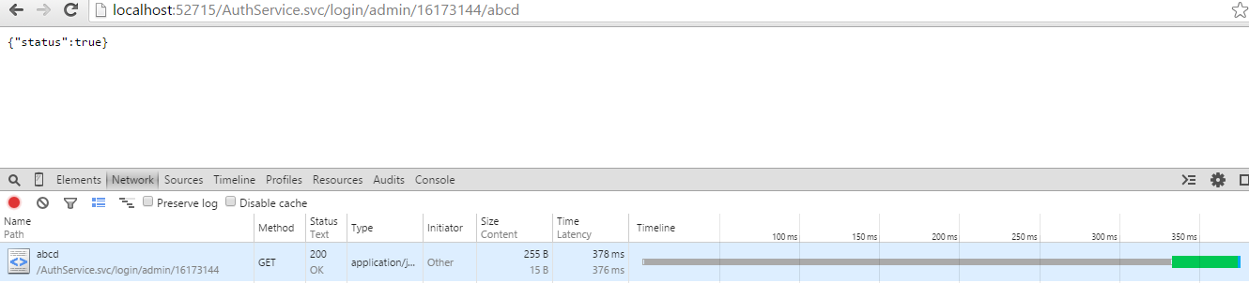

**Admin Registration Response Time:**

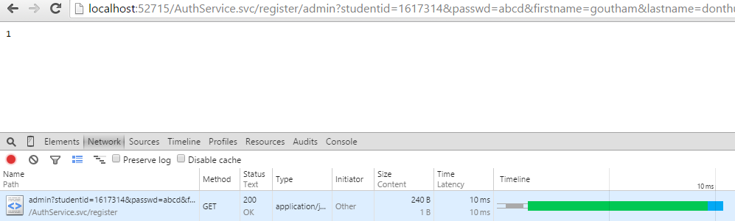

**Assign Volunteer:**

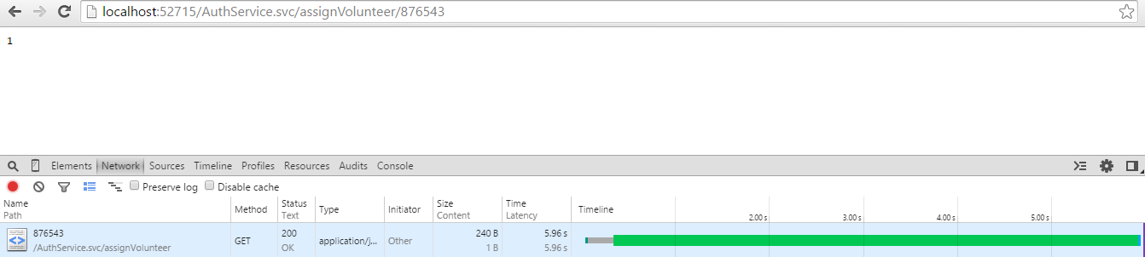

**Results of the Performance:**

* The results include the high response time for login(<300ms).
* The response time for registration is around (700ms).
* The response time for Volunteer is variant. It depends on the number of assigned students for the registered volunteer, involve sending them mails. The response time we observed for 10 students assigned when a volunteer is registered is 38 secs.

**Deployment:**

The whole deployment of the project can be found in here

<http://kc-sce-cs551.kc.umkc.edu/aspnet_client/Group6/PickMeUpService>

As described in the report there are 3 stories completed in this iteration. You can find url of two 3 web services created for this iteration.

**Webservice URLS:**

Admin Login Service:

<http://kc-sce-cs551.kc.umkc.edu/aspnet_client/Group6/PickMeUpService/AuthService.svc/login/admin/{usrn}/{pwd}>

Admin Registration Service:

[http://kc-sce-cs551.kc.umkc.edu/aspnet_client/Group6/PickMeUpService/AuthService.svc/ register/admin?studentid={sid}&passwd={pwd}&firstname={fname}&lastname={lname}&email={eid}&gender={sex}&phone={ph}&address={address}&university={university}](http://kc-sce-cs551.kc.umkc.edu/aspnet_client/Group6/PickMeUpService/AuthService.svc/get/volunteer/%7busrn%7d)

Admin Home Service:

http://kc-sce-cs551.kc.umkc.edu/aspnet_client/Group6/PickMeUpService/AuthService.svc/ login/admin/{usrn}

**Report GitHub URL:**

[https://github.com/rpqt7/PickMeUp/blob/master/PG6-Increment 3_Report.docx](https://github.com/rpqt7/PickMeUp/blob/master/PG6-Increment%203_Report.docx)

**Project Management:**

**ScrumDo Link:** <https://app.scrumdo.com/projects/pickmeup/board#/view/iteration/1473>

**Implementation status report:**

**Work Completed:**

**Description:**

1. As an admin, I want to login so that I can get access to the application.

Responsibility: Prabha, Rahul

Time Taken: 20 hrs

Contribution: 100%

1. As an admin, I want to create an account and have admin privileges so that I can access all the students and volunteer details.

Responsibility: Anvesh, Rahul

Time Taken: 20 hrs

Contribution: 100%

1. As a admin I want to access all the details of students and volunteers so that I can see who is assigned to who for pick up.

Responsibility: Satish, Anvesh

Time Taken: 20 hrs

Contribution: 100%

**Work To be completed:** None

**Issues/Concerns:**

* There are few compatibility issues using Visual Studio 2010 & 2013
* Data type conversion issues when inserting data into the database
* Build issues were there